Immersive Technologies to Launch All New Simulator Line-up at MINExpo 2016

Immersive Technologies’ Advanced Equipment Simulators are at the heart of the mining industry’s leading operator training and workforce development solutions. These solutions have a track record beyond compare in the delivery of quantified safety, efficiency and unscheduled maintenance improvements infield, measured by companies including BHP Billiton, Rio Tinto, Vale, Glencore, Barrick, Newmont, Freeport-McMoRan and Anglo American.
Developed using expertise and data gained through working with 270 mining operations globally, Immersive Technologies will launch three brand new Simulators targeted at delivering even greater business improvement to their customers.
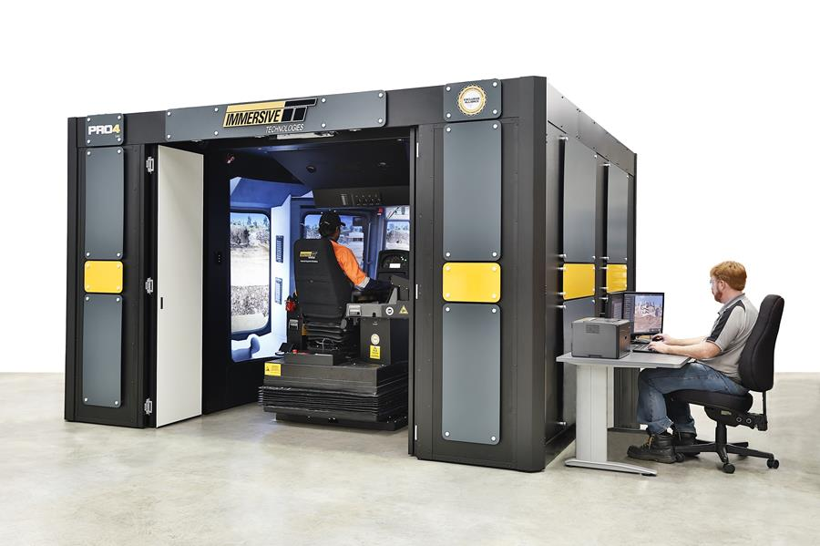
The PRO4 will be unveiled for the first time publically at MINExpo, along with the announcement of its new innovations. The PRO4 has been specifically designed for surface mining and delivers cutting edge technologies with realism at a level not previously seen by the mining industry.
The PRO4 builds on the huge success of its predecessors the PRO3-B and before that the AES Series 2B which became the global standard in the mining industry over the past 16 years, training over 150,000 mining equipment operators across 40 countries.

