Press
Nuremberg, September 7, 2016
Siemens AG  Communications  Head: Clarissa Haller | Wittelsbacherplatz 2  80333 Munich  Germany
Reference number: PR2016090388PDEN

Industrial Ethernet switches for reliable communication in harsh environments

- Scalance XP-200 in low-profile design with high IP65/67 degree of protection
- Extended temperature range from -40 °C to +70 °C
- Gigabit-capability and Power-over-Ethernet with a total power of 120 W
- Particularly suitable for the oil and gas industry, rail and road vehicles

With its new Scalance XP-200 product line, Siemens offers compact Industrial Ethernet switches for the setup of electrical line, star and ring structures. The devices feature a low-profile, robust metal enclosure with a high degree of protection (IP65/67) and a wide operating temperature range from -40 °C to +70 °C. This provides flexibility to be deployed outside the control cabinet, both indoors and outside. In addition, the layer 2 switches offer a choice of industry-specific certifications. For example, they are approved for hazardous locations in zone 2 (ATEX, IECEx, cULus HazLoc) and therefore suitable for the oil and gas industry. Furthermore, particularly rugged versions are available for use in rail or road vehicles.

There are two versions available with different numbers of ports: Scalance XP208 has eight ports while Scalance XP216 has 16. In addition to Fast Ethernet ports using the M12 connection system (D-coded), Scalance XP216 also offers up to four Gigabit ports in M12 connection technology (X-coded).

Both versions are available as particularly robust EEC versions (EEC = Extended Environmental Conditions). The devices are certified in accordance with the EN 50155 and EN 45545 railway standards and are suitable for use both trainside and trackside. They are also approved for use in road vehicles with e1/E1 requirements. To supply end devices with energy, Scalance XP208PoE EEC and Scalance XP216PoE EEC offer a total output of 120 watts in accordance with the Power-over-Ethernet (PoE) standard IEEE 802.3at Type 2.

All of the switches in this product line feature a redundant power supply which enables reliable operation even if one power supply system fails.
As in the case of all managed layer 2 switches of the Scalance X series, users can transfer configurations from one switch to another when replacing a device by simply plugging in the C-plug. This minimizes downtimes. The device status can be quickly and easily determined on site by means of the clear LED indicators, without the need for additional devices such as PGs.

A five-year warranty applies to the new Scalance XP-200 devices, as for all Scalance products.

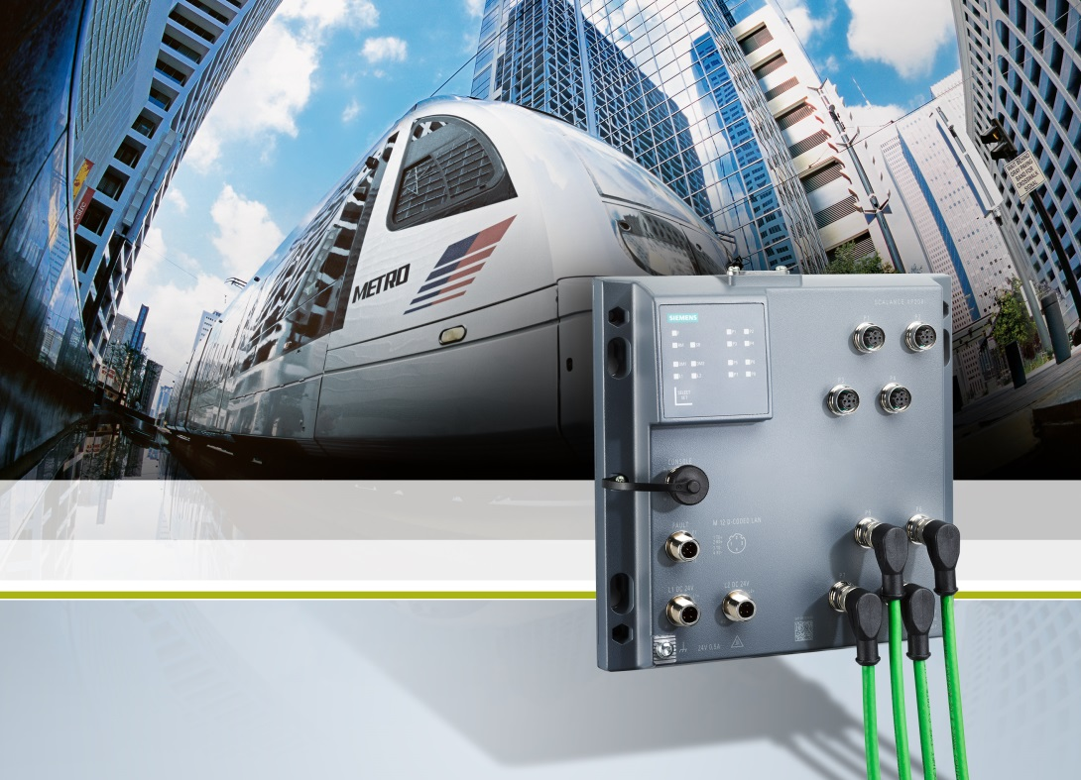
With its new Scalance XP-200 product line, Siemens offers compact Industrial Ethernet switches for the setup of electrical line, star and ring structures. The devices feature a low-profile, robust metal enclosure with a high degree of protection (IP65/67) and a wide operating temperature range from -40 °C to +70 °C.

This press release and a press picture are available at
http://www.siemens.com/press/PR2016090388PDEN

Additional information can be found at www.siemens.com/xp-200

Contact for journalists:
Dr. David Petry
Phone: +49 (913) 172-6616; E-mail: david.petry@siemens.com

Follow us on social media:
Twitter: www.twitter.com/siemens_press and www.twitter.com/SiemensIndustry
Blog: https://blogs.siemens.com/mediaservice-industries-en

Siemens AG (Berlin and Munich) is a global technology powerhouse that has stood for engineering excellence, innovation, quality, reliability and internationality for more than 165 years. The company is active in more than 200 countries, focusing on the areas of electrification, automation and digitalization. One of the world’s largest producers of energy-efficient, resource-saving technologies, Siemens is No. 1 in offshore wind turbine construction, a leading supplier of gas and steam turbines for power generation, a major provider of power transmission solutions and a pioneer in infrastructure solutions as well as automation, drive and software solutions for industry. The company is also a leading provider of medical imaging equipment – such as computed tomography and magnetic resonance imaging systems – and a leader in laboratory diagnostics as well as clinical IT. In fiscal 2015, which ended on September 30, 2015, Siemens generated revenue of €75.6 billion and net income of €7.4 billion. At the end of September 2015, the company had around 348,000 employees worldwide.
Further information is available on the Internet at www.siemens.com.

