

PRESS INFORMATION
For Immediate Release

Date: 6th September 2016
Ref: PR0053
Contact: Paul Fears
E-mail: press@buntingeurope.com

Solving the Problem of Metal Contamination at the K Plastics Show
Metal Separation Equipment will be displayed by Bunting Magnetics Europe in Hall 10 on stand G16 at the International Plastics and Rubber trade fair, K 2016 (19th – 26th October 2016 Dusseldorf, Germany.
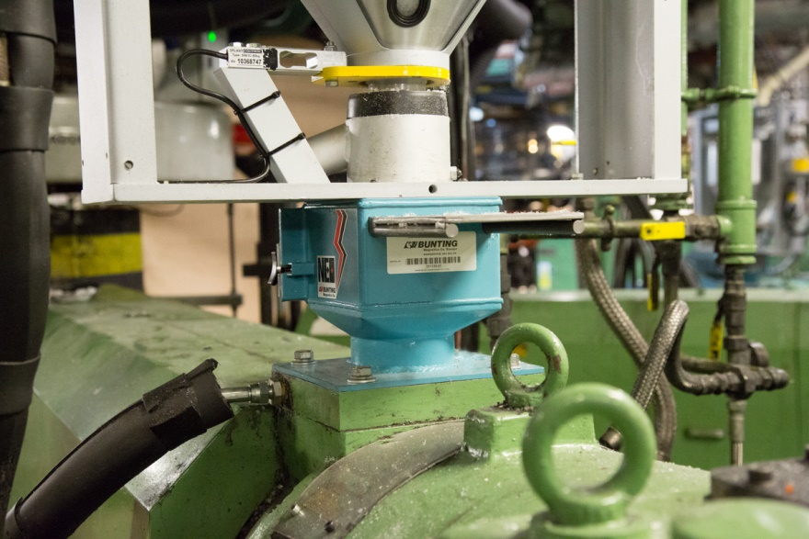
Figure 1 - FF Drawer Magnet installed in a plastics manufacturing plant
Bunting Magnetics is one of the world’s leading suppliers of Magnetic Separators and Metal Detectors to the Plastics and Rubber industries, with the Global headquarters in Newton, Kansas, USA and the European manufacturing headquarters in Berkhamsted in Hertfordshire, UK.
On stand G16 at K 2016, Bunting will be displaying a range of Metal Separation equipment including Magnetic Separators and Metal Detectors. Metal contamination is a common problem within the Plastics and Rubber industries, causing product defects and damaging processing equipment. The type of metal can range from small fine metal to larger screws or nuts and bolts. Effective removal is essential and achieved by using the right Metal Separation equipment installed in the correct location.
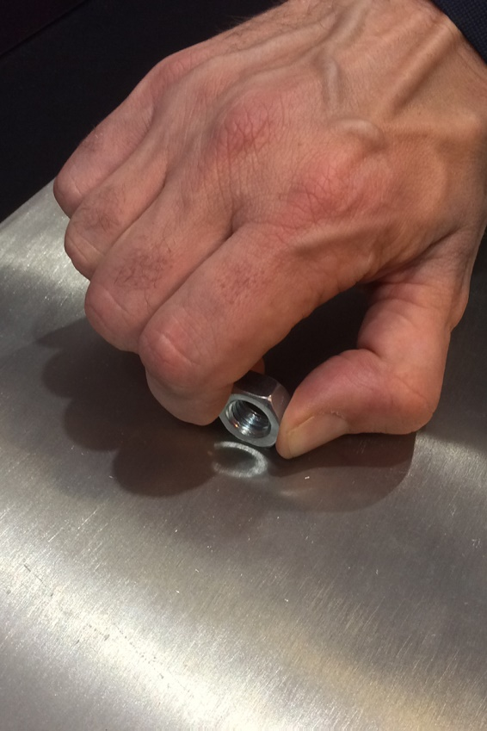
“On our stand at K 2016, we want to show visitors the effectiveness of our Magnetic Separators and Metal Detectors in removing metal from the plastics and rubber production process,” explained Dave Hills, Bunting’s Head of Sales.
Figure 2 - Attempting to pull a steel bolt off the surface of a Plate Magnet
Bunting will be displaying a working Metal Separator (a combination of a Drawer Magnet Grate following by a Metal Detector) and Quicktron Metal Detector. Also on the stand will be production-sized examples of FF Drawer Magnets, Plate Magnets and Tube Magnets where customers can experience the strength of the magnetic force by attempting to pull steel bolts off the surface.
“When customers visit our stand we want to show them the separation capabilities of our equipment. It is one thing to say a piece of ferrous or non-ferrous metal will be separated, but another to actually show it happening,” said Hills.
“We will be demonstrating the Metal Separator. Metal contaminated plastic will be gravity fed into a feed hopper and immediately into a FF Drawer Magnet. Here magnetic particles are captured before the remaining plastic falls into the Metal Detector which identifies and rejects any non-ferrous metals,” said Hills.
Hills is excited by the opportunities at the show. “The K Show is the number one exhibition for the Plastics and Rubber industry in Europe and one of the premier events on the global calendar. We [Bunting] have been helping the industry solve their metal contamination problems for decades. Having a stand and demonstrating our Metal Separators is really important and we look forward to helping companies address the costly issue of metal contamination.”
For further information on separating and removing metal with Magnetic Separators or Metal Detectors, please contact the Bunting technical sales team on sales@buntingeurope.com or visit the website www.buntingeurope.com.

High resolution JPGs of all the images provided with this press release are available from the Bunting Press Officer, Paul Fears. Also, for additional information on this recent installation or any other issue mentioned in this article please contact Paul on 07909 103789 or press@buntingeurope.com or visit www.buntingeurope.com.

Please can we request that the Press Office is advised of any editorial coverage by sending:
- Print copies to Paul Fears, Press Officer, Bunting Magnetics Europe Ltd, 12 Wakelin Close, St David’s Manor, Church Village, CF38 1GA
- Please email links to online coverage to press@buntingeurope.com


Northbridge Road
Berkhamsted
Hertfordshire
HP4 1EH, UK
Tel: +44 (0) 1442 875081

