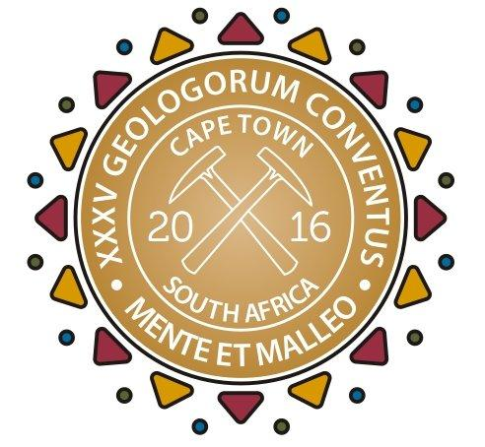
MEDIA RELEASE
Feel the earth move: South Africa welcomes the 35th International Geological Congress
IMMEDIATE RELEASE 30 August 2016
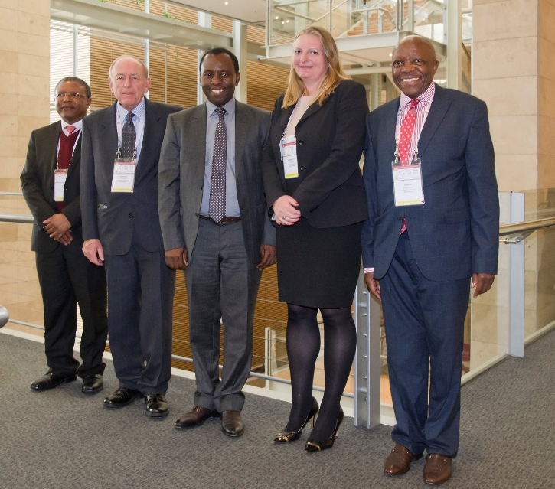
CAPTION: The Honourable Minister of Mineral Resources, Mr Mosebenzi Zwane, opened the prestigious 35th International Geological Congress (IGC) at the Cape Town International Convention Centre (CTICC) yesterday morning, 29 August 2016. From left to right: Professor Phuti Ngoepe, (Chairman of the Board – Council for Geoscience), Dr Richard Viljoen (co-president of the 35th IGC), Honourable Minister Mosebenzi Zwane (MP), Dr Jeannette McGill (co-president of the 35th IGC) and Simon Sikhosana (acting CEO – Council for Geoscience). Photographer: Frank Kurmmcher
More than 4000 delegates from 120 countries flocked to the Cape Town International Convention Centre (CTICC) yesterday to mark the opening ceremony of this prestigious International Geological event, occurring for the 35th time since 1878.
“It is fitting that the geological community has returned to the African continent,” said Minister of Mineral Resources, Mr Mosebenzi Zwane. Welcoming delegates to the “cradle of humankind” – “phecelezi’ imvelaphi yabantu” – Minister Zwane reminded the delegates that the 1929 IGC conference, in Pretoria, had “catalysed advancement of the profession resulting in a significant improvement and a better understanding of the country’s and regional geological prowess”. This year's programme affords the opportunity to retrace some of these field trips and examine the advances made over the 87 intervening years.
This ground-breaking exposure to the wonders of South Africa's geology enabled global mining concerns in particular to make major commercial breakthroughs. Now, it is time to square economic opportunity with social and environmental responsibility. As Minister Zwane put it, “It is both untenable and unjustifiable to sustain a structurally flawed economic model that places the African continent at the bottom quartile of development, notwithstanding its natural resources endowment that spans land, minerals, upstream petroleum and others.”
The best way to turn this state of affairs around is to reverse the brain drain from the country and keep African knowledge assets in-house. To this end, according to professor Richard Viljoen, co-president with Dr Jeannette McGill (one of the Global 100 Women in Mining for 2016) of the 35th IGC, bridging distances between African geoscientists is a key goal of the IGC.
“This conference is not for South Africa alone but all of Africa,” Viljoen added. “The idea was to attract as many African delegates as possible.”
Another key idea is bringing the earth sciences closer together with other economic sectors, especially agriculture and tourism.
Minister Zwane emphasised this point: “There is an emerging narrative on the tension between mining and agriculture. But the truth is that through the creative cross application of the knowledge bases indicate that the two are not necessarily mutually exclusive. The connection between mining and agriculture is evidenced through geo-scientific research and interventions aimed at attaining food security.”
Empowerment is high on the agenda. Said Minister Zwane, “It is critical to empower women and the youth in geosciences to ensure continuity of the profession and its contribution to humanity. The African Continent has the largest population dividend that we must leverage.”
That's why, according to Viljoen, “The intention is to cater to the needs and aspirations of young earth scientists through the GeoHost programme.” This is an assistance programme designed and developed by the IUGS to help young, financially disadvantaged geoscientists attend the IGC.
“The Young Earth Scientists Network is well represented at this year's conference; they can now network and interact with world authorities to gain a broader perspective,” said Viljoen.
“Today you can have artificial intelligence displacing industries. How do you really pioneer the future? Geoscience is standing on the edge of an immense opportunity.”
Dr Greg Botha, senior specialist scientist at the Council for Geosciences (CGS) and secretary-general of the 35th IGC concludes: “The week is only just started. Delegates can look forward to a host of geological topics ranging from climate change and shale gas to environmental issues and geological professionalism.”
For more information about the IGC visit http://www.35igc.org/. Join the 35th IGC Facebook page at https://www.facebook.com/35thigc/. Registrations are also still open. Visit http://www.35igc.org/Verso/60/Registration to sign up.
###
Released by Reputation Matters
Media contact
Nalene de Klerk
Mobile Number: 083 302 1528
nalene@reputationmatters.co.za

