September 2015
Out with the old, in… with the new Eurotech vacuum components catalogue for the glass industry

Eurotech has adapted its catalogue for the glass industry to its new corporate design. Design engineers and users get 124 pages’ worth of suitable vacuum components, hand held suction cups and lifting devices for their handling tasks – tailored especially to the glass industry.

Eurotech vacuum components are based on a modular construction system. You can combine a wide range of seals with different base plates. The possible combinations are detailed clearly in a fold-out table located in the contents part of the catalogue to help you choose the right seal and base plate. The catalogue is divided into six chapters. It contains all relevant data including type designations, article numbers, technical parameters and drawings. Its informative introduction offers a lot of knowledge about vacuums.

A new chapter on “hand-held suckers” has been added. It contains accessories that are easily matched with the right hand-held sucker thanks to the included cross-references. The last chapter presents a selection of Eurotech lifting devices, which are predestined for glass handling thanks to their use of their own vacuum components.
The catalogue for the glass industry is now available in a print and digital version. Visit www.euro-tech-vacuum.de to download the digital edition or order a print copy free of charge via the contact form.

The digital version allows you to click the table of contents to jump directly to your desired products. Interactive buttons bring you back to the next higher-level table of contents for easier navigation. Waste no more time scrolling through endless lists of items.

Figures: 1.704

Company profile:
euroTECH offers handling and transport solutions in the field of vacuum technology. The company develops customer-specific vacuum systems and components for automated handling tasks. Thanks to the euroTECH modular construction system, the components can be flexibly adjusted to meet individual customer requirements and spare parts can be installed in a quick and cost-saving manner.

Pictures:
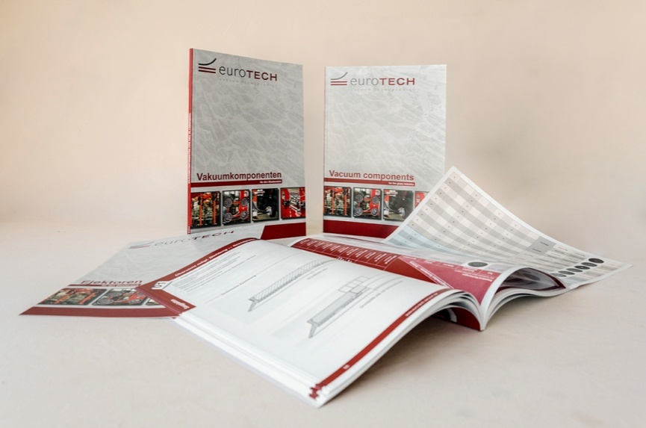
Image 1: The new Eurotech vacuum components catalogue for the glass industry

The enclosed picture material can be used by you free of charge. Please send us a copy after the publishing.

