Harnessing Change: Why Future Success Belongs to the First Movers…

By Kate Stubbs – Managing Executive Business Development and Marketing, Barloworld Logistics

As market commentators continuously point out, South African businesses of all sizes and across sectors are having a torrid time. Faced with global uncertainty, political flux, and ongoing technology-driven disruption, merely staying afloat as become a Herculean task. However, as the results of the Barloworld Logistics 13th annual supplychainforesight survey have revealed, there is a stubbornly optimistic streak among local business leaders and decision-makers. Indeed, many are looking to capitalise on key opportunities and trends that have very clearly emerged from a complex and fast-moving business ecosystem.

“Arguably, one of the biggest opportunities lies in an organisation’s ability to not only navigate change, but to foresee key trends and thus outmanoeuvre competitors,” says Kate Stubbs, Head of Marketing, Barloworld Logistics. “This capability, however, does not come about through sheer luck or talent – it is something that savvy leaders are beginning to institutionalise and embed in the very fabric of their business operations.”

An example of this type of ‘institutionalised adaptation’ can be found in General Electric, which has been very openly abandoning its traditional ‘Global 2000’ approach, and behaving more like a nimble Silicon Valley startup. By implementing a company-wide programme labeled FastWorks, GE is essentially embedding lean startup practices into its operations. Most notably, this involves moving away from strict approval processes to instead allow employees to make seamless changes to their projects, as well as change strategies and direction very quickly and autonomously.

Testament to how seriously the company has been taking the adoption of new business practices, it enlisted tech pioneer and author Eric Ries to help develop the FastWorks programme, based in part on his global bestseller, The Lean Startup. As explained in the 2011 book, Ries’s philosophy is designed to help companies foster innovation and bolster product development by building imperfect early versions, releasing them to customers, soliciting feedback, and then pivoting or adapting the products when required.

Translating Ideas into Action…

“As we move into a period of higher market disruption and greater economic and political uncertainty in South Africa, it is critical for local companies to replicate this type of experimentation and forward-thinking,” notes Stubbs. “Interestingly, our most recent survey indicated that businesses have identified key opportunities – but the question remains as to how committed they are to pursuing them and translating them into tangible strategies…”
The survey revealed that transport and infrastructure ranked the highest in terms of an opportunity to impact growth both significantly and positively.

“This opportunity affects almost every sector of business enterprise in South Africa, although it requires major investment in order to move the dial,” explains Stubbs. “Infrastructure development is not just related to transport but to power, water, telecommunications, social structures and support facilities.”

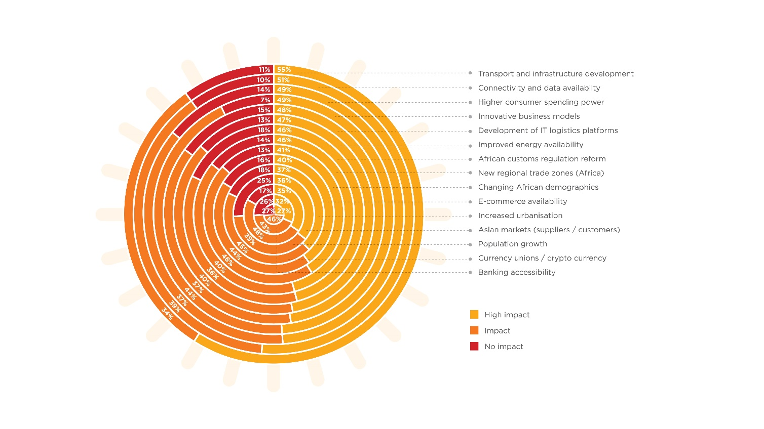

Unsurprisingly, technology-related elements rank highly as opportunities, spanning data and connectivity issues, IT platforms and e commerce - all of which will benefit from higher consumer spending power.

“Each of these perceived needs create opportunities across almost every segment of commerce and industry,” adds Stubbs. “The overall response to the perception of future opportunities points to a high level of enthusiasm and excitement of 69%, while 24% expressed their concern, indicating varying levels of optimism.”

Without doubt, those companies that can turn this optimism into real ideas, and duly transform ideas into cleverly designed strategies will achieve future success. As the tough global market reality becomes ever more apparent, it is evident that the only way to truly harness change is to view change as the biggest business opportunity in and of itself.

Words : 581

About the author:
Kate Stubbs - Managing Executive Business Development & Marketing, Barloworld Logistics
With a degree in Business Management, Ms Stubbs joined Barloworld Logistics in 2002, prior to which she worked both locally and internationally. She joined the executive committee of Barloworld Logistics in 2011 as Executive: Marketing and Communications and through her recent promotion to Managing Executive: Business Development and Marketing, has expanded her responsibilities to lead the Business Development and Sales teams across all regions.
Ms Stubbs is driven by a passion to make connections between people, ideas and concepts come alive and transforming them into commercial reality. Her areas of specialisation include: sales and marketing, client services and corporate communication. She is a primary source of thought leadership for the supply chain management industry, and has been intimately involved in conceptualising, developing and producing strategic insights on business and supply chain trends in the form of the annual Barloworld Logistics’ supplychainforesight research study.
She brings 14 years’ experience at Barloworld Logistics to bear in her current role overseeing the development and execution of sales and marketing activities for Barloworld Logistics across all regions. She enjoys turning 'big picture thinking' into solutions that result in action and value creation.
“Creating innovative solutions and looking for opportunities in a world of constant change are a great source of inspiration to me,” she explains.

About Barloworld Logistics:

Over 70% of potential savings and service enhancements in a supply chain come from the re-engineering and integration of logistics processes. Barloworld Logistics is South Africa's leading integrated logistics and supply chain Management Company, and a fast-growing global player. They create strategic advantage for their clients by optimising and integrating the client's logistics processes and information flows, thereby radically reducing their costs and increasing their service levels. Log onto www.barloworld-logistics.com for more information

