PRESS RELEASE
CONTACTS
Anna Dörfling - Snr Marketing Coordinator (Tenova Pyromet) anna.dorfling@tenova.com
T: +27 11 480 2072
Sara Secomandi – Chief Communication Officer (Tenova) sara.secomandi@tenova.com
T +39 02 43848110

Innovative PGM furnace for Northam Platinum on track for 2017 handover

Johannesburg, South Africa, August, 01, 2016 – High capacity furnace and smelting plant specialist, Tenova Pyromet announced today that it has completed 50 % of Northam Platinum Limited’s new platinum group metals (PGM) furnace at its Zondereinde smelter operation in Thabazimbi, South Africa, having met all major project milestones to date. As a result, handover of a fully operational 20 MW furnace is on track for August 2017.
Project milestones achieved include the first steel being raised on site in mid July 2015 as per the scheduled project date. This is the first of over 1,000 tonnes of structural steelwork that will be used on the project. More than 20 % of the civil structures are also complete, while the placing of the 12 m diameter furnace shell marks another significant milestone, with the site establishment of the mechanical installation contractor.
Access to the first two floors of the furnace building is scheduled to be achieved prior to the 2016 December recess in South Africa, with a number of local and international deliveries scheduled to take place by then.
The contract, which was awarded to Tenova Pyromet by Northam Platinum in 2015, will support Northam Platinum’s planned growth in PGM production, which requires the flexibility to process high chromite, low base metal and high sulphur contained concentrates. With Northam’s innovative pyrometallurgical approach and Tenova Pyromet’s technical ability, Northam will be able to operate the furnace either as a submerged arc operation or brush arc operation and will therefore have a sufficiently broad operating range to accommodate feedstock with a widely varying mineralogy.
Tenova Pyromet’s scope on the project covers the PGM smelting furnace, feed system and off gas handling plant, as well as the furnace building and all associated civil works, infrastructure and services. State-of-the-art technology that forms part of the technical solution includes Tenova Pyromet electrodes, copper cooling elements, and off gas handling and furnace controller.

“We are acknowledged worldwide for the advanced technical solutions we provide our clients, but the progress that has been made to date, right on schedule, in the construction activities is also testimony to Tenova Pyromet’s strength in managing the execution of such major and innovative projects,” says Andre Esterhuizen, general manager, sales and marketing, Tenova Pyromet. “Such large projects call for the interfacing of numerous contractors on site and, in the case of this project, within an operational plant.”
Tenova Pyromet is a leading company in design and supply of high capacity AC and DC furnaces and complete smelting plants for production of ferroalloys, base metals, slag cleaning and refining. Tenova Pyromet also designs and supplies equipment for material handling and pre-treatment, alloy conversion and refining, granulation of metal, matte and slag, furnace off-gas fume collection and treatment, and treatment of hazardous dusts and waste. Tenova Pyromet has several technologies to reduce operating costs and increase production efficiencies.
Tenova is a leading supplier of technological solutions and engineering services for the metals and mining industries, including key segments of the metallurgical process as well as in the mining value chain. Combining innovative engineering with process and automation expertise, Tenova delivers a full range of value-add solutions from greenfield projects, equipment and technology solutions to modernization upgrades and service packages. Passion for technology and a commitment to understanding needs of its global customer base are the key drivers of Tenova’s business operations.
For more information visit www.tenova.com

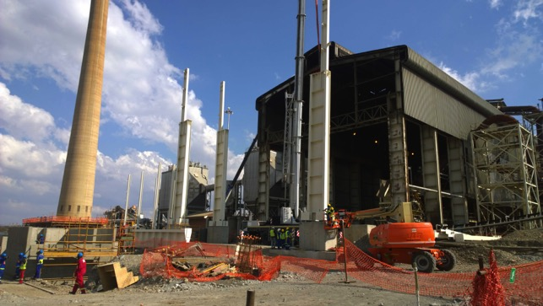
Construction underway and on target, installing Northam Platinum’s new PGM furnace at its Zondereinde smelter operation in Thabazimbi, South Africa.


