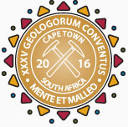
MEDIA RELEASE
The importance of geosciences in mining
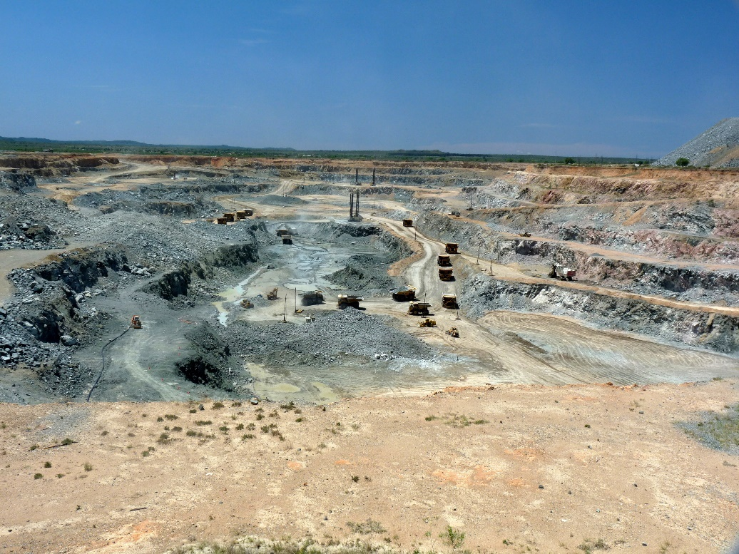
CAPTION: Geoscience is important for a country’s economy because it defines the mineral resource and ensures the success of mining ventures. Mogalakwena, the world’s largest opencast platinum mine, (above) is located in a complex geological setting near Mokopane, Limpopo, South Africa and supplies a great percentage of the world’s platinum. [Photo credit: Morris Viljoen]
The 35th International Geological Congress (IGC) is taking place from 27 August to 04 September 2016 at the Cape Town International Convention Centre. Mining development is one of the main areas where geoscience directly contributes to a country’s economy. Africa is destined to supply a large portion of the world’s future mineral resources through the application of various scientific approaches. For this reason, the theme: ‘Resourcing Future Generations,’ will feature prominently at this year’s IGC.
“There is no mining without geology,” says Aberra Mogessie, President of the Geological Society of Africa and convenor of a special symposium on the African Mining Vision (AMV) at the IGC. “Geological, geochemical and geophysical investigations form part of the foundation for successful exploration of mineral occurrences,” says Mogessie.
Richard Viljoen, the co-president of the IGC, agrees and adds that effective mining, particularly of lower grade or erratic ore bodies, is based entirely on good quality geoscientific input. “Without accurate and reliable geoscientific input, most mining ventures are likely to fail,” says Viljoen.
The AMV was established by the African Union (AU) Heads of State and Government in 2009 in an attempt to better manage the continent’s mineral resources. “Africa holds an abundant amount of mineral resources, but so far it has not been able to reap the full potential benefits on offer,” says Viljoen. The AMV aims to effectively utilise Africa’s mineral resources through transparent, equitable and optimal exploitation of all mineral resources to underpin broad-based sustainable growth and socio-economic development on the continent. This will be achieved through:
- Building the capacity of regional and national minerals-related institutions;
- Investing in improved physical, social and human capital;
- Developing technology and products in the mining sector; and
- Strengthening environmental and social management.
The African Minerals Development Centre (AMDC) was founded by the AU Commission to provide strategic support to the AMV and is responsible for tying together all the various earth science initiatives and projects across the continent. “As part of their efforts, the AMDC is currently developing the Geological Mineral and Information System Strategy (GMISS) to provide the necessary guidance and support to AU members in improving their geological and mineral information systems,” says Mogessie. “This will encourage investment across the whole mineral value chain,” he adds.
“The GMISS views geological and geospatial information as crucial for several important economic, social, legal and environmental applications in mining and broad development processes in Africa,” says Mogessie.
“The themes of this year’s IGC will shed some light on the purpose and roles of the AMV, AMDC and GMISS. A comprehensive understanding of the industry from a wide range of mining industry geologists from all over the world will also be presented,” says Viljoen. “We are providing an opportunity for key players within the African mining industry to gain invaluable knowledge at the IGC. It should not be missed!”
Registrations for the congress are open. Visit http://www.35igc.org/Verso/60/Registration to sign up or book your exhibit on http://www.35igc.org/Verso/44/Exhibitors-Advertisers.
For more information about the IGC visit http://www.35igc.org/. Join the 35th IGC Facebook page at https://www.facebook.com/35thigc/.
###
Released by Reputation Matters
Media contact:
Nalene de Klerk
Mobile Number: 081 411 6089
nalene@reputationmatters.co.za

