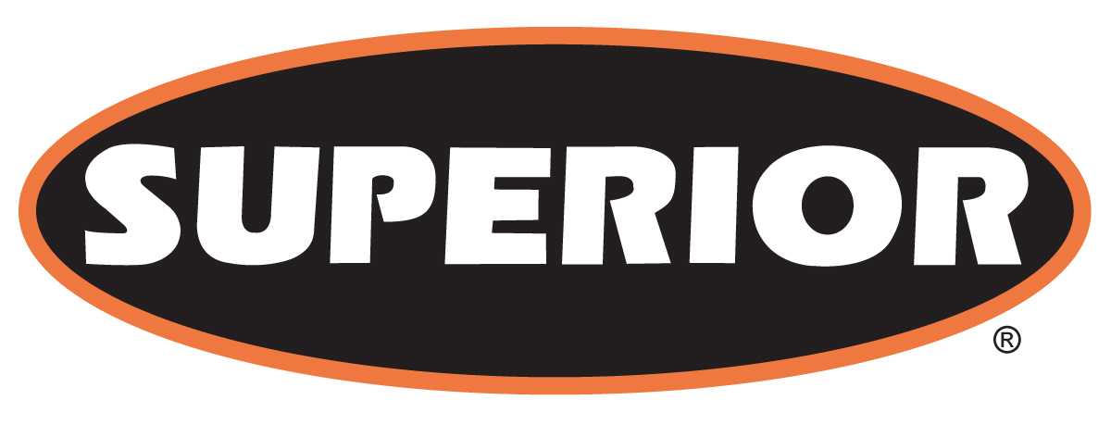

FOR IMMEDIATE RELEASE

July 27, 2016

35-Year Industry Veteran Peter Patterson Joins Superior in Sales Role

Morris, Minn. – Superior Industries, Inc., a U.S.-based manufacturer and global supplier of bulk material processing and handling systems, has appointed Peter Patterson as territory sales manager throughout central and western Canada. In his new role, Patterson will work alongside bulk material producers and Superior's dealers in the region to showcase the manufacturer's growing line of crushing, screening, washing and conveying solutions.

Patterson comes to Superior after most recently holding the position as a regional sales manager at Metso. He originally joined the industrial machinery manufacturer in 2005. Before Metso, Patterson was in a sales position at Wehr and was in maintenance operations for nearly two decades before that at 3M.

Today, Patterson lives and works from his home in Southeast Ontario, Canada. He was a volunteer firefighter and training captain for 15 years and a past associate director of the Ontario Stone, Sand & Gravel Association.

About Superior Industries, Inc.
Superior Industries engineers and manufactures groundbreaking, bulk material processing and handling equipment and cutting-edge machinery components. From its headquarters in Morris, Minnesota, USA, the manufacturing firm supplies bulk crushing, screening, washing and conveying systems for industries including construction aggregates, mining, bulk terminals, agriculture, power and biomass. In addition to its home plant in Minnesota, the 44-year-old Superior operates from additional facilities in Arizona, Georgia, Illinois, Michigan and Nebraska, USA; Alberta and New Brunswick, Canada; and three locations in Brazil to serve South American markets.

For more information, contact:
Corey Poppe, Marketing Communications Manager
315 East State Highway 28
Morris, Minnesota 56267 U.S.A.
+1 (320) 589-2406
corey.poppe@superior-ind.com
www.superior-ind.com

