PRESS RELEASE
Barloworld’s supports Enactus in driving youth-led social change
- University students compete nationally for the opportunity to represent South Africa at the 2016 Enactus World Cup in Toronto with Barloworld’s help

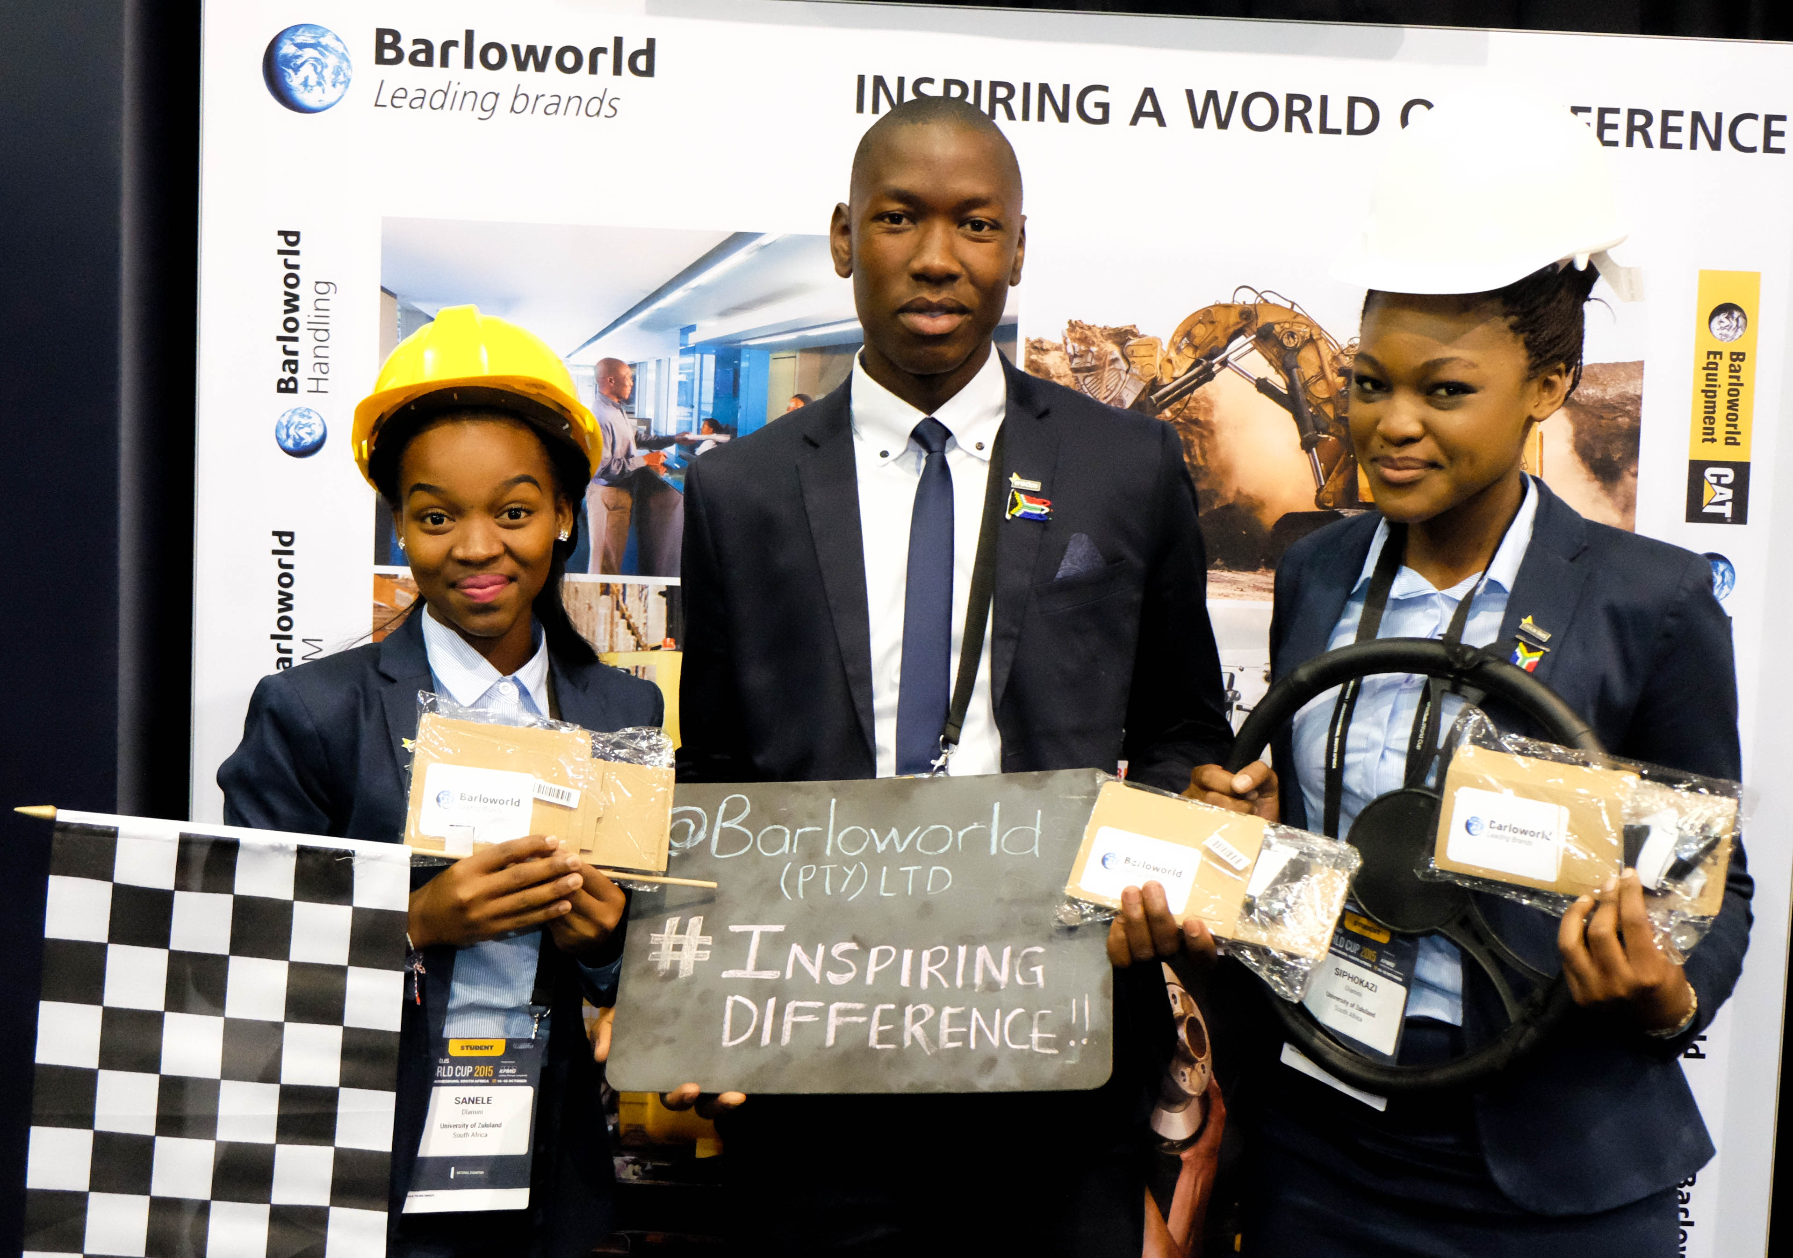
YOUTH POWER: At the global Enactus World Cup last year Barloworld showcased innovation with a custom-built application made for Google Cardboard 3D headset.

TUESDAY, 26 JULY, JOHANNESBURG – The Barloworld Group, an Enactus partner since 2012, became involved in the inspiring initiative – which uses the power of entrepreneurial action to transform lives and shape a better, more sustainable world – after it was moved by students’ innovative ideas and actions.

“We supported Enactus World Cup last year, this first time the event was hosted on the African continent, where we experienced directly our youth’s enthusiasm and commitment to the development of global communities. Some incredible ideas and projects have emerged through Enactus, contributing significantly towards solving some of the challenges facing many of our communities,” says Barloworld’s CEO Clive Thomson.

Enactus, a non-profit, was launched in South Africa in 2001 and has demonstrated exceptional growth over the past 15 years. From a mere four universities at the time, today Enactus is represented across 26 institutions globally. Last year, South African Enactus teams volunteered almost 320 000 hours to change people’s lives through 112 enterprising projects nationally.

The Enactus national competition kicks off tomorrow through to Thursday at the Sandton Convention Centre, with over 1 100 delegates expected to attend, including over 750 student representatives and observers from 21 public and two private higher education institutions in South Africa. Business and academic mentors, with leading business executives serving as judges (over 160 in total), will complete these numbers.

Barloworld is very focused on education, and aside from Enactus, it also supports learning development programmes at various levels within the education system.
“Through the Barloworld Trust, we invest millions in carefully selected interventions which address some of South Africa’s most pressing problems in a structured, systematic manner. We adopt a structural approach to social responsibility, meaning we look at the cause of the problem and try find creative solutions to solve these.”
The winning team of this national event will go on to compete with 35 other countries in a bid to win the 2016 Enactus World Cup. Last year’s national champions, the University of Zululand, took South Africa to the semi-final round in the World Cup. The Cup was ultimately won by the United Kingdom team.

ENDS. (346 words)

FOR THE EDITOR:

Barloworld is a distributor of leading global brands, provides integrated rental, fleet management, product support and logistics solutions. The company was established in 1902 in South Africa, making it one of the country’s oldest companies. Inspiring leadership, a reputation for ethical conduct, innovation and a commitment to giving back has ensured Barloworld’s longevity over the past 113 years.

The core divisions of the group comprise Equipment and Handling (earthmoving, power systems, materials handling and agriculture), Automotive and Logistics (car rental, motor retail, fleet services, used vehicles and disposal solutions, logistics management and supply chain optimisation). We offer flexible, value adding, integrated business solutions to our customers backed by leading global brands.

Barloworld has a proven track record of long-term relationships with global principals and customers. We have an ability to develop and grow businesses in multiple geographies including challenging territories with high growth prospects. The company currently has operations in 22 countries around the world with approximately 76% of just over 19 700 employees in South Africa.

__________________________________________________________________________________

Issued on behalf of Barloworld Ltd. For more information, please contact Lauren Human on +27 78 253 9160 or at laurenh@meropa.co.za

