Press Release
Issued by: Water Research Commission
Date issued: 28 October 2016

Heading: Saving water - TVET students receives vehicle from AquaTrip

Sixteen Johannesburg schools are benefiting from an innovative new technology that is set to help them identify leaks and save water. Aquatrip is a new technology that was selected for demonstration by the Water Technologies Demonstration Programme (WADER) – a joint programme of the Department of Science and Technology (DST) and the Water Research Commission (WRC). WADER, in partnership with the South African Local Government Association (SALGA), put out a call for innovative water and sanitation technologies and solutions that will contribute to improving water conservation, efficient use, cost-effectiveness and efficient management of water and waste in the municipal environment.

The AquaTrip device, which functions in a similar way to an electricity trip switch, identifies unknown leaks and plumbing failures, including, taps left running, leaking toilets and urinals, leaking or failed appliances, and cracked pipes or leaking fittings. The device also identifies and prevents all inadvertent or accidental over-use.

AquaTrip is permanently installed on a water line and the technology monitors the flow of water over time during specific set times that are predetermined by the customer. If the device detects a leak, it will either shut the water off, if appropriate, or notify the customer and stop water wastage. AquaTrip does not alter consumption patterns – it only eliminates water wastage.

In partnership with Johannesburg Water, 20 high water consumption schools were identified where the technology could be tested on a pilot scale. A total of 16 schools were finally selected for the two-month pilot phase due to complex reticulation at some schools. Six plumbing graduates from South West Gauteng College were brought into the project for the plumbing work at the various sites.

Dr Manjusha Sunil, the WADER Manager at WRC said that the savings ranged from 15-91% at the selected schools. She added that the system detected and reacted to leaks over 755 times in two months without impacting the schools or users.

William Moraka of SALGA, one of the project sponsors said that such projects can be done with the willingness and cooperation between public and private sectors. At the heart of the project is local job creation and, importantly, water savings using technological advances. However, sustainability deepens largely on the beneficiaries’ ability and capability to undertake operations and maintenance.

The pilot project demonstrated that the AquaTrip can achieve savings arising from leak detection and reduction in wastage, says Dr Valerie Naidoo, Executive Manager for Business Development and Innovations at the WRC. However, she highlighted that an extended period of monitoring is essential for the quantification of the long-term benefits.

AquaTrip CEO , Mr Chris de Wet Steyn said that the 6 TVET College plumbing graduates were trained to assist in the installations and plumbing work for the programme. As a result of this AquaTrip has now engaged two of these graduates to continue their work on other water savings programmes in Gauteng.

At an official celebration at the WRC, Mr Chris de Wet Steyn handed over the keys of a fully equipped vehicle to the students as their commitment to create sustainable employment opportunities for the graduates of the TVET colleges. AquaTrip plans to continue with the relationship.

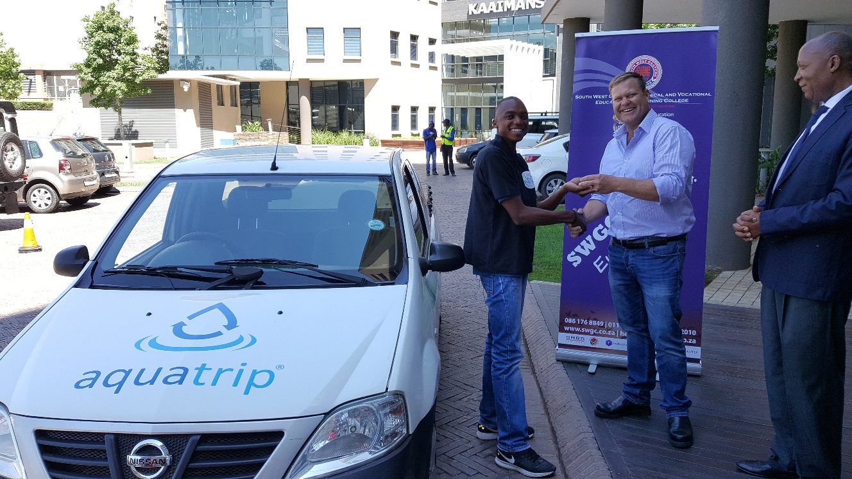

(from L to R : student Tyse Nawane, Chris de Wet Steyn (AquaTrip), principal Dan Nkosi of South West Gauteng TVET College

End.

To find out more about the WRC go to www.wrc.org.za

Adriaan Taljaard
Media
012 330 9036
adriaant@wrc.org.za

